Kohl Faul



Project Plan

Forever Gears

# Introduction

## Problem Domain

The customer needed an application for the floor manager to take stock control of items in his store. He also didn't always have time to type into type in the item name. and he also needed a login and sign up feature.

## Needs of the Customer

Hands free input for item names,

* Hands free input for item names
* sign up and login
* User friendly design
* Online database
* Voice feedback

## Goals of the Project

* Saving the customer time and effort
* Securing his/her information with a login system

# Technical Feasibility Issues

## Hardware

* Basic android supported device
* Wi-Fi and Data needed

## Software

* API level 23
* Access to internet need for most features

# Features Included

* Text to speech
* Speech to Text (Google Supported)
* Firebase database for Data storage
* Login and sign up security
* Nav drawer for Navigation
* Martial design for aesthetic appeal

\*Help Screen in App\*

# Screens

## Login With Nav Draw to Navigate to Sign up

# C:\Users\Kohl\Desktop\Screenshot_20171011-145151.pngC:\Users\Kohl\Desktop\Screenshot_20171011-150319.png

## Sign up with Nav Draw to Navigate to Login

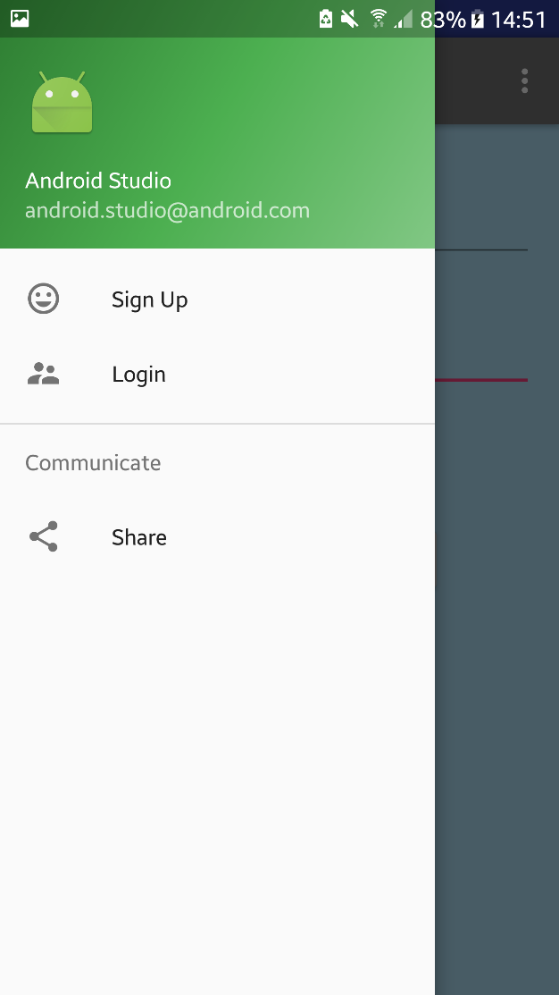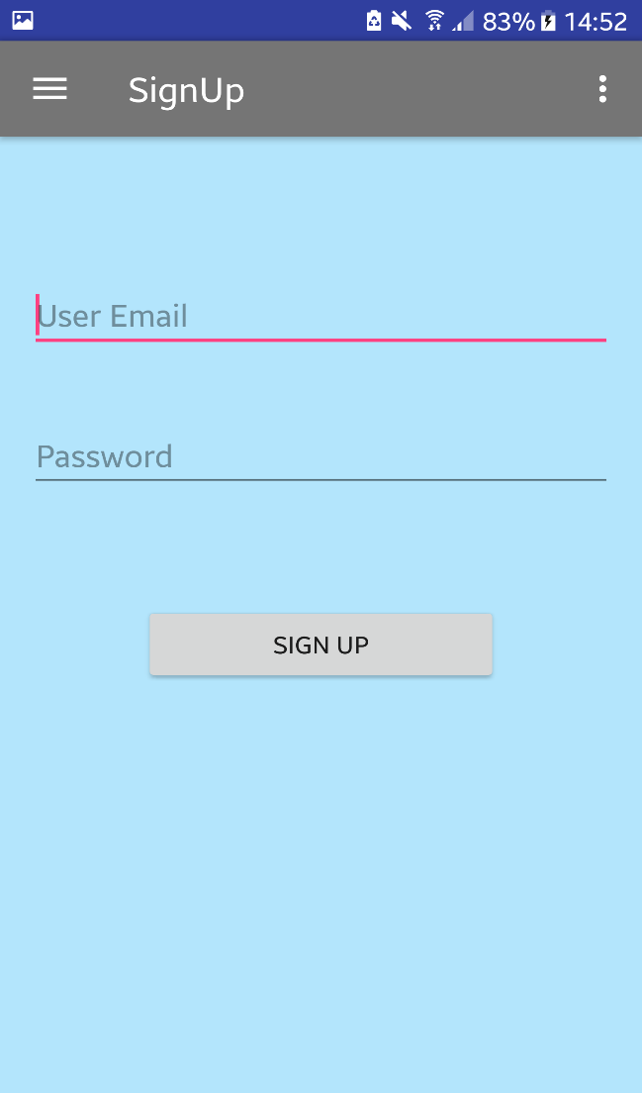

## Main Screen with Nav Draw to logout C:\Users\Kohl\Desktop\Screenshot_20171011-151439.pngC:\Users\Kohl\Desktop\Screenshot_20171011-145233.png

# Google speech to text that inputs the speech to text and places it in the EditText field. C:\Users\Kohl\Desktop\Screenshot_20171011-145238.png